ionic start ionic4-angular-news tabs --type=angular

cd .\ionic4-angular-news

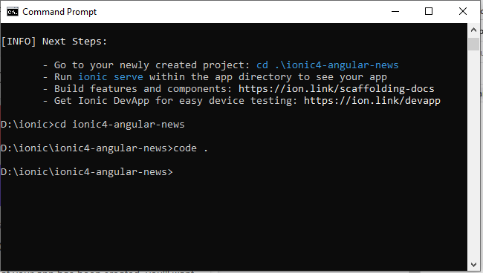

Buat page baru dengan nama “news”

ionic g page news --dry-run

ionic g page news

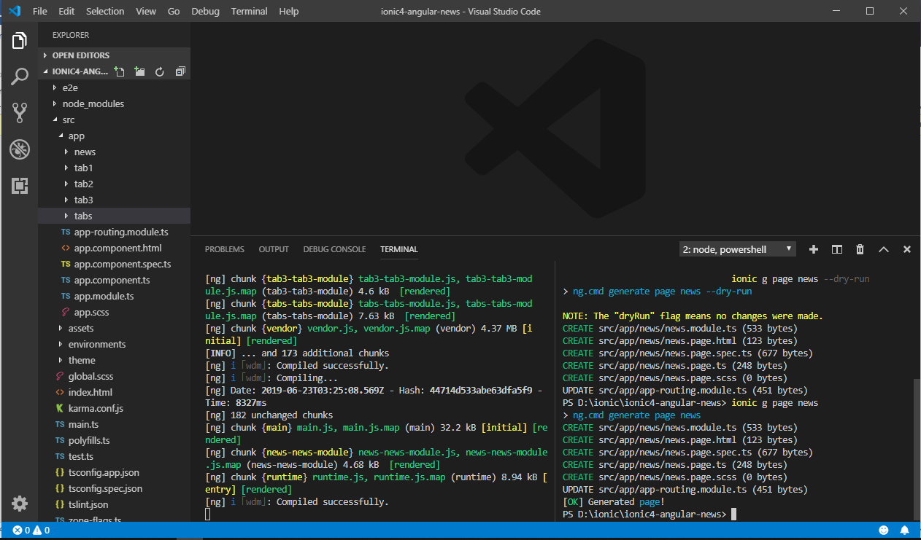

ionic g page news-single

edit file /apps/tabs/tabs.module.ts

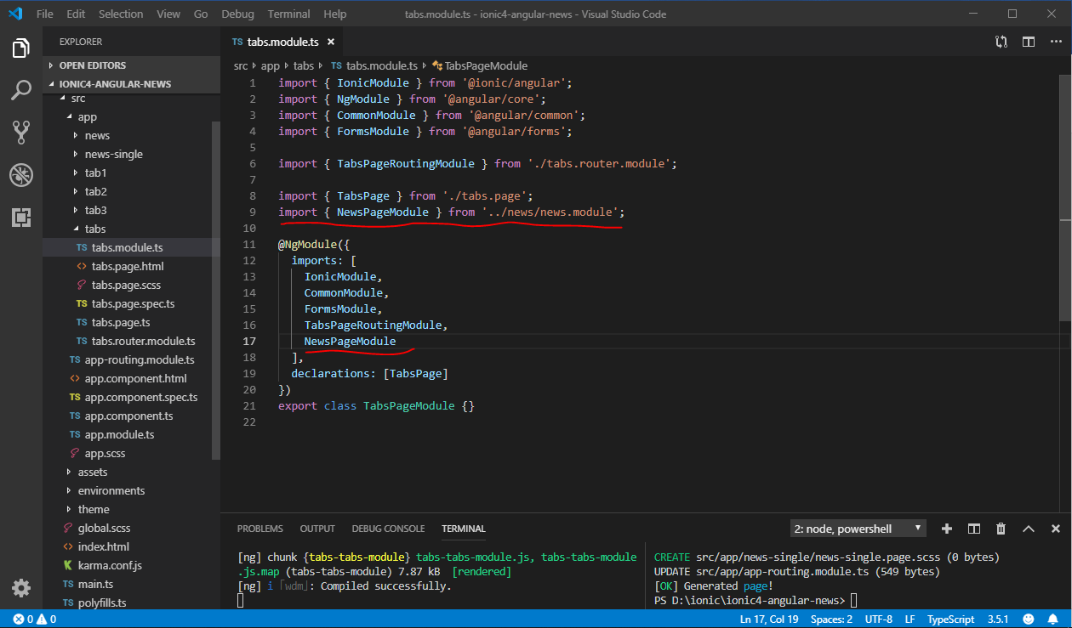

/apps/tabs/tabs.router.module.ts

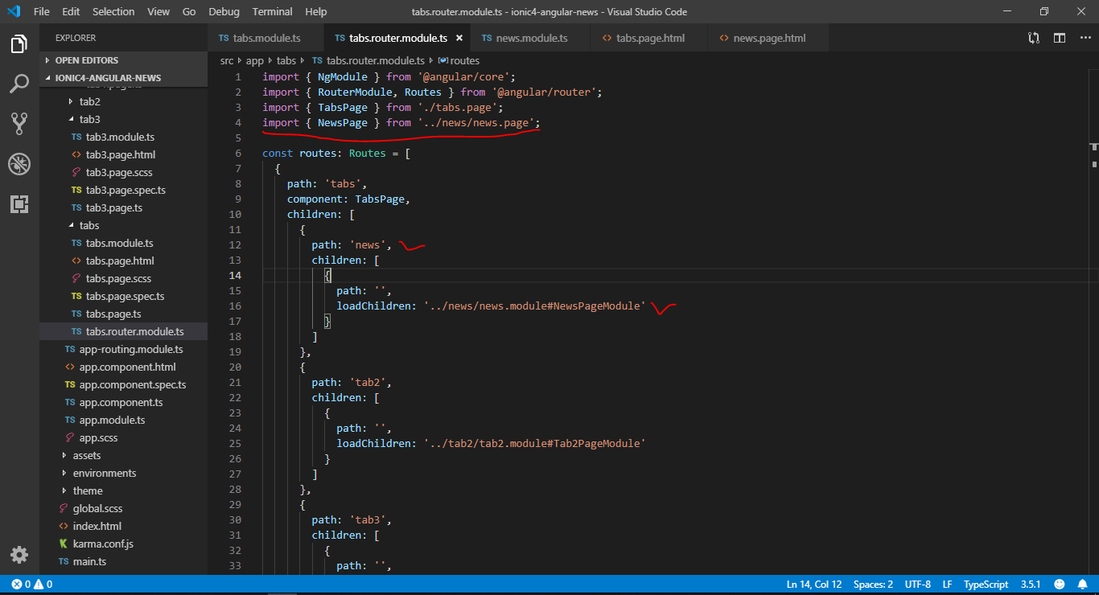

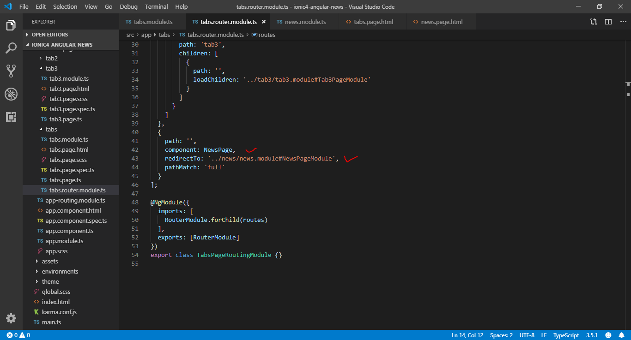

/apps/tabs/tabs.page.html

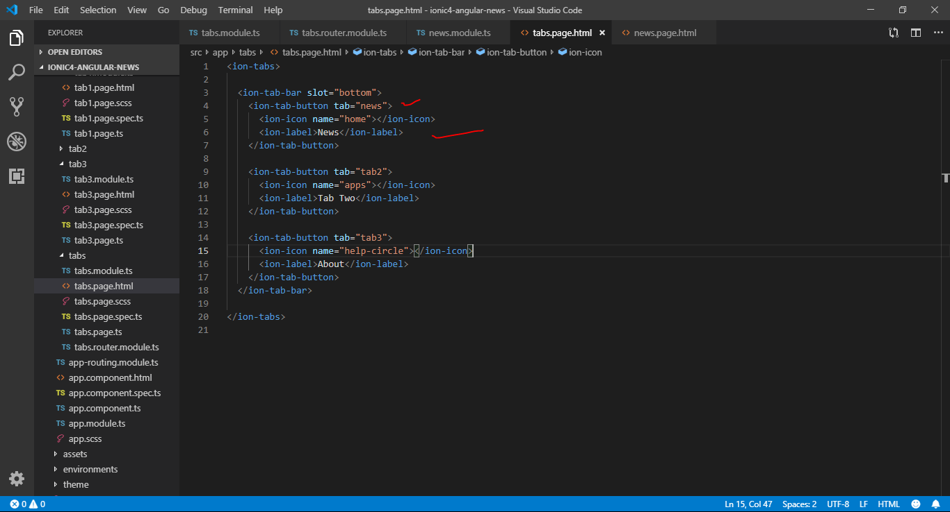

Generate Service

Ionic generate

Select service

Name : news

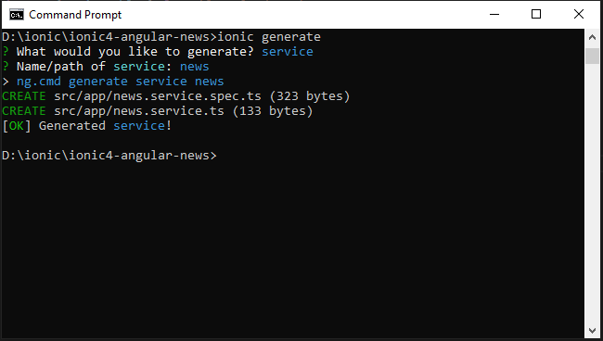

environtment.ts

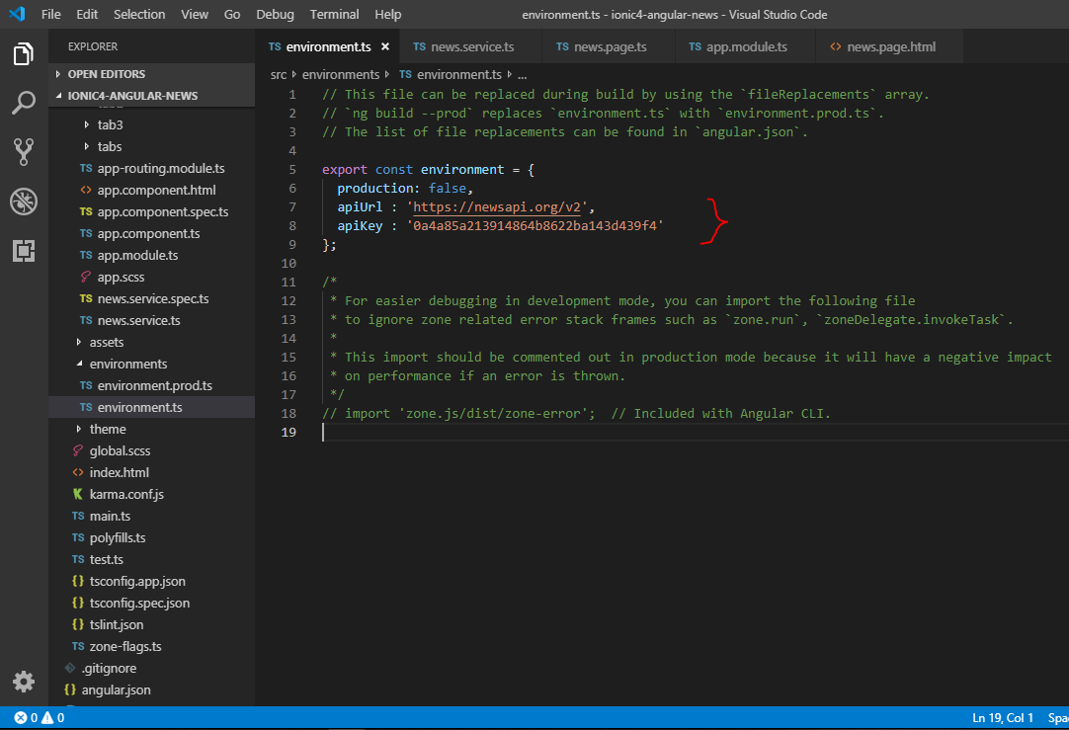

app.module.ts

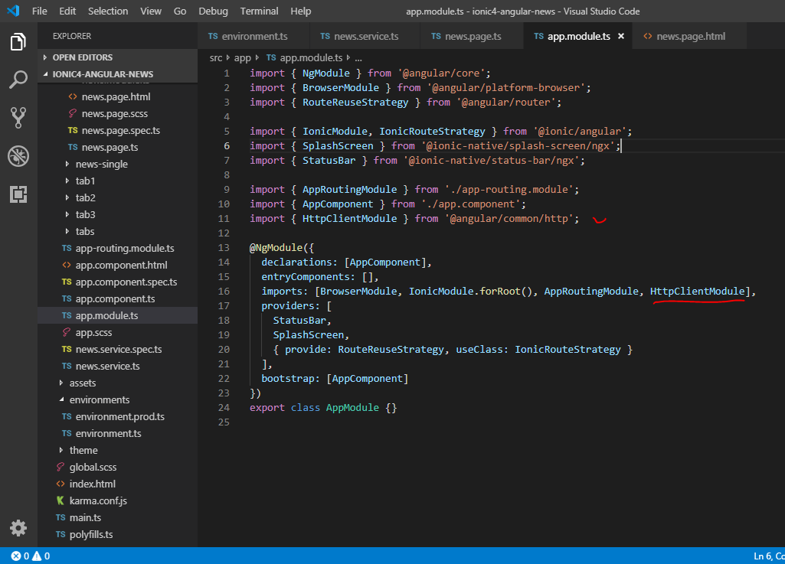

news.service.ts

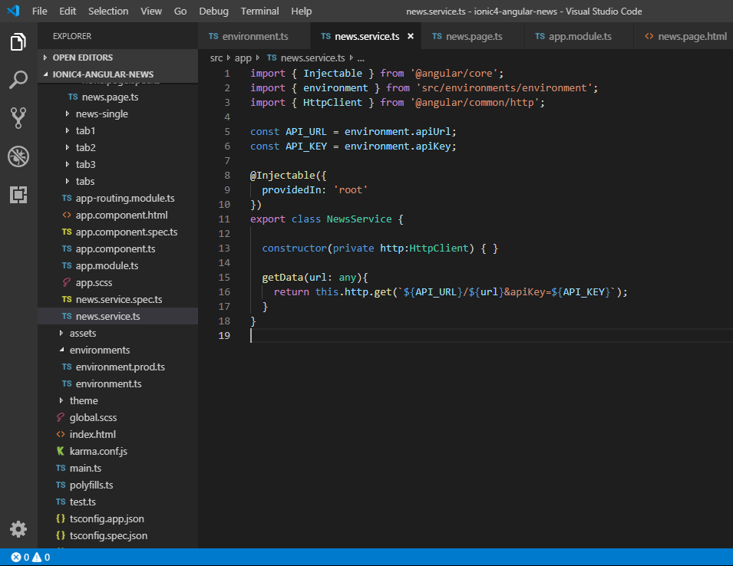

news.page.html

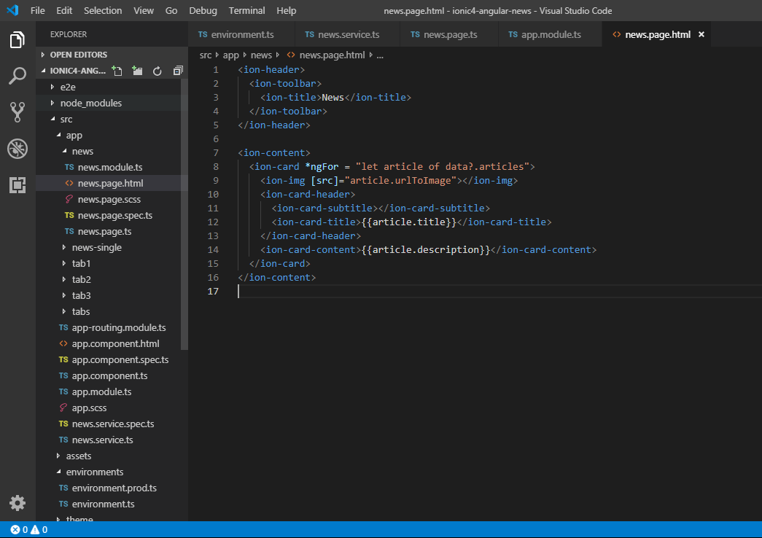

SINGLE ARTICLE

$ generate page news-single

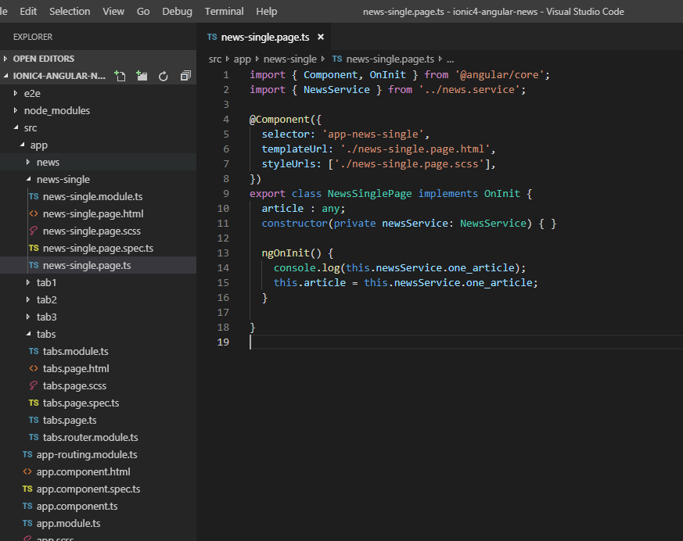

news-single.page.html

